**B.V.V.S**

**BASAVESHWAR ENGINEERING COLLEGE, BAGALKOTE**

**DEPARTMENT OF COMPUTER APPLICATIONS (MCA)**



**A**

**Project Report**

On

**“Smart Dustbin”**

ACADEMIC YEAR 2023-2024

MCA 1st Semester

**Student Name:**  **Project Coordinator**

Chetan Melavanki Prof. C. M. Jangin

Laxmanna A Goudar Asst Prof. Dept. of MCA

Sanganbasava Toravi BEC,Bagalkote

MCA 1st sem

**Abstract**

The main objective of the project is to design a smart dustbin which will help in keeping our environment clean and also eco-friendly. We are inspired from Swaach Bharat Mission. Nowadays technologies are getting smarter day-by-day so, as to clean the environment we are designing a smart dustbin by using Arduino.

Smart Dustbin as its name represents it works smartly or we can say that it is an automatic dustbin. it works like when you will come in front of this dustbin it will open automatically with the help of a servo motor. so there is some sensor work to detect the object in front of the dustbin.

**Introduction to Project**

* Most of the cities, towns and villages in India are not well designed to facilitate the suitable garbage collection methods.
* Common Public dustbins are filling over with the garbage and no one is concerned to clear them up as and when they get completely packed with overflowing garbage.
* Keeping in view of this big problem, it will be a good suggestion to do something to deal with this unmanaged waste and from this, we have designed a simple system called IoT based Smart Dustbin using Arduino, Ultrasonic Sensor and Servo Motor, where the lid of the dustbin will automatically open itself upon detection of human body.

IoT devices are pieces of hardware, such as sensors, actuators, gadgets, appliances, or machines, that are programmed for certain applications and can transmit data over the internet or other networks.

**Objectives**

The main objective of this project is to

* Design and build a prototype for an automatic open dustbin that can automatically open the lid when it detects the people who want to throw out their trash. It also can detect the level of the trash that inside the dustbin.
* To get familiar with the Arduino and the respective sensors how to use them for a cause.
* To analysis the dustbin program and set it up according to the physical distance for best Working.

**Modules**

* IOT Device with Arduino UNO Module.
* IOT Device with Ultrasonic Sensor Module.
* IOT Device with Servo Motor Module.
* IOT with Buzzer Module.

**Components required**

**Software Requirements**

Operating System : Windows 8 or Above

Programming : C++, Java

IDE : Arduino

**Hardware Requirements**

Processor : i3 above

Ram : 4GB (Minimum)

Hard Disk Space : 40GB

**Data Flow Diagram**

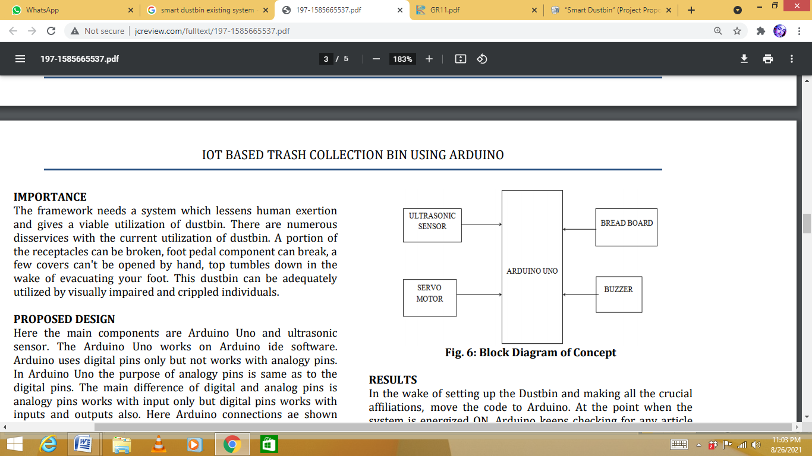

### Use Case Diagram

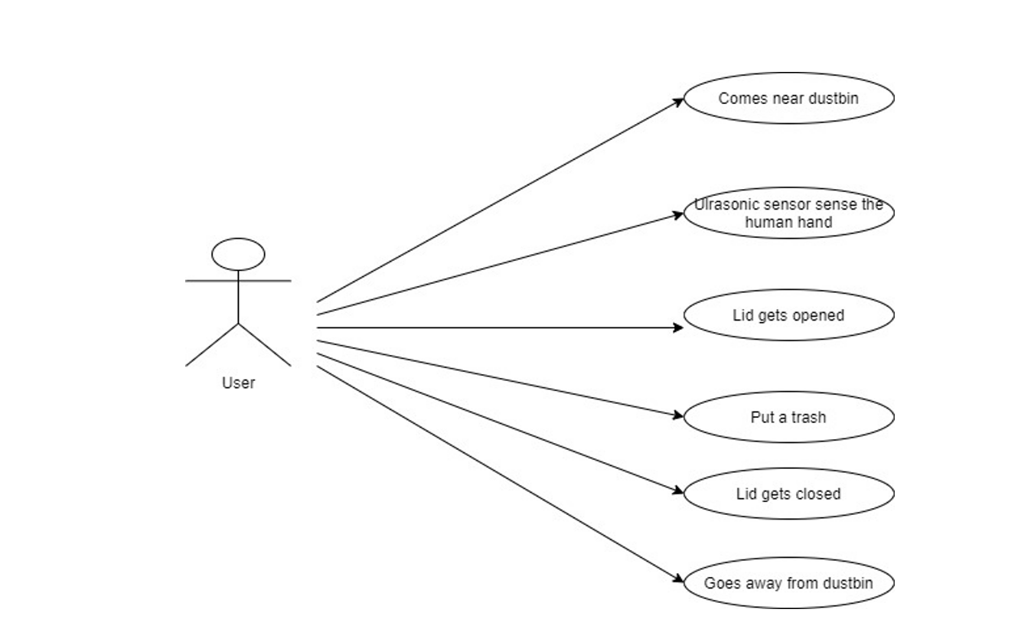

**Architecture Diagram**

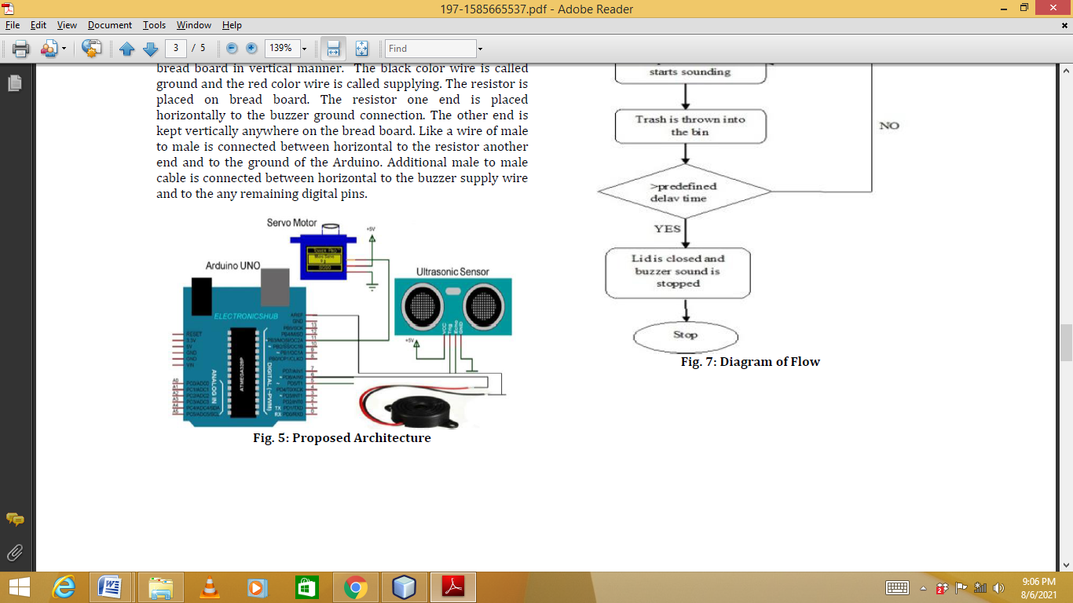

**Validation Report(Screen Shots)**

**-Arduino UNO board**

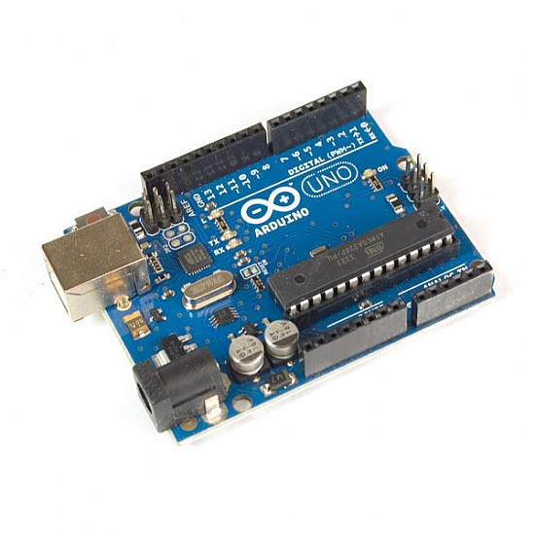

**-Ultrasonic Sensor**

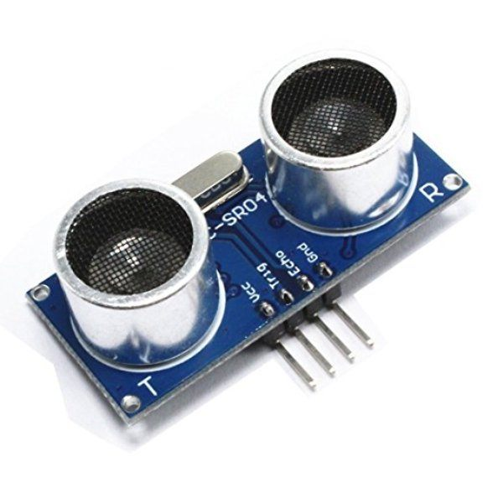

**Servo Motor**

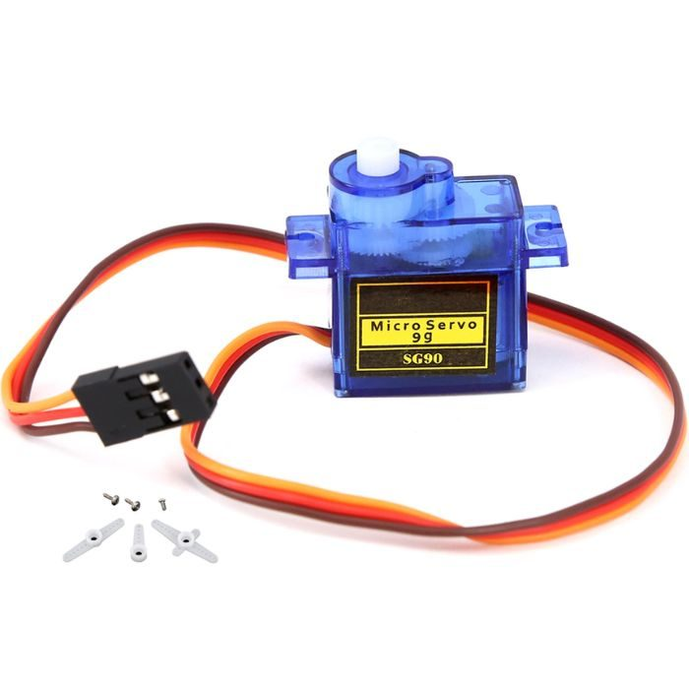

**Buzzer**

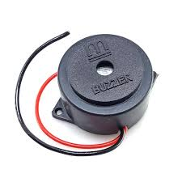

**Bread Board**

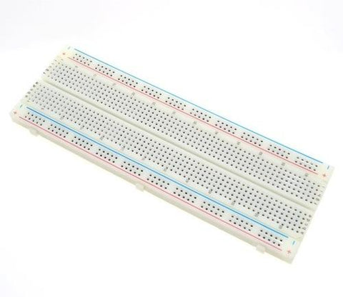

**Code and Output Window**

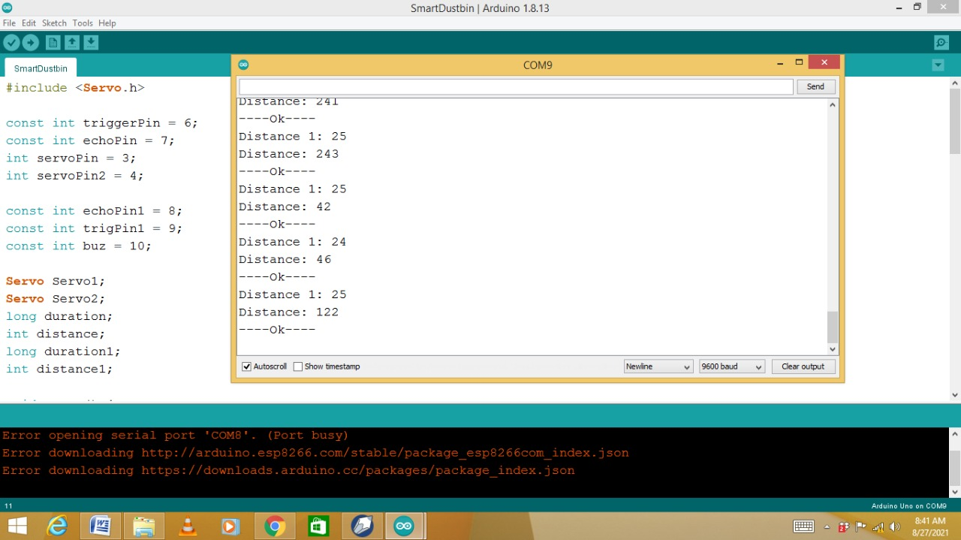

**Openaed Dustbin lid**

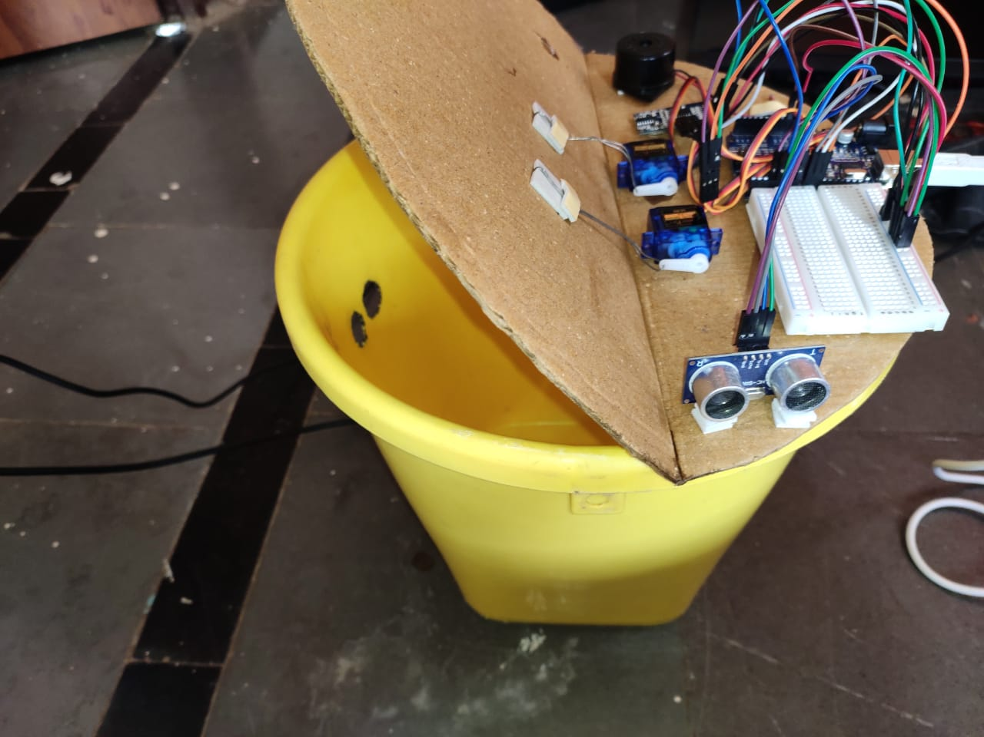

**Closed Dustbin lid**

